**1. Delay-Bandwidth Product for Links in Series**

Consider three nodes in series. Node A is connected to node B via a 150 Mbps fiber optic link, 2500 km in length. Node B is connected to node C via a 1 Mbps link, 2 km in length. The links are full duplex. The rate of transmission errors on the links, the time to switch a packet at node B, and the time to transmit an ACK are all negligible. A large file is to be sent from node A to node C, and there is no other traffic on the links. Packets are 1.5 KB, including headers.

1. Ignoring reliability and packet headers, what is the maximum throughput that can be achieved (in Mbps)? Explain.

According to the P&D textbook 1.5, the speed of light in optical fiber is . Since the time to transmit of an ACK is negligible, I use the one-way latency here.

The transfer time of A to B is:

The transfer time of B to C is:

Thus, the total transfer time is

The maximum throughput can achieve is:

**The maximum throughput that can be achieved is 0.49 Mbps.**

1. What is the round trip time from A to C?

**Thus the round trip time from A to C is 0.02502 s**

1. What is the roundtrip bandwidth delay product for the path from A to C? (Specify the units you use).
2. Suppose an end-to-end sliding window protocol is used with SWS=RWS. What size of SWS is optimal?

Since the bottleneck of this path is 1 Mbps, the transmit time of this file is:

According to b, the one-trip-delay between A and C is 12.51 ms.

Then, the optimal window size is:

**Thus, the optimal size of SWS is 3.**

1. Why wouldn't you want SWS to be many times larger than the value you suggested in part d?

Since this protocol deliver 3 packet every RTT seconds, if the SWS value is much larger than 3, the overall delay will be too large, other connection might become idle and the resource is wasted.

**2. Media Access Control**

Suppose two nodes, A and B, are attached to opposite ends of a 450 m cable, and that they each have one frame of 500 bits (including all headers and preambles) to send to each other. Both nodes attempt to transmit at time t = 0. Suppose there are four repeaters between A and B, each inserting a 10-bit delay. Assume the transmission rate is 10 Mbps, and CSMA/CD with backoff intervals of multiples of 512 bits is used. After the first collision, A draws K = 0 and B draws K = 1 in the exponential backoff protocol. Ignore the jam signal.

1. What is the one-way propagation delay (including repeater delays) between A and B in seconds? Assume that the signal propagation speed is .

The speed-of-light propagation delay is:

Plus the overall repeater delays:

**The one-way propagation delay is .**

1. At what time (in seconds) is A’s packet completely delivered at B?

The time to transmit taken by the first collision is:

After the first collision, A resends the frame immediately because it choses K = 0, and takes

Plus two speed of light propagation delay

**At time , A’s packet completely delivered at B.**

1. Now suppose that only A has a packet to send and that the repeaters are replaced with bridges. Suppose that each bridge has a 10-bit processing delay in addition to a store-and-forward delay. At what time, in seconds, is A’s packet delivered at B?

If the store-and-forward bridges are used, the transmit delay of one link will be:

There are 5 links between A and B, thus, the transmit delay is .

Plus 4 processing delay,

And the speed-of-light propagation delay, .

At time , A’s packet is delivered at B.

**3. Ethernet Timing**

This problem is about the Ethernet/IEEE 802.11 access protocol. To be definite, suppose that if a host detects a transmission while it is transmitting a frame, then: (i) if the host has already transmitted the 64 bit preamble, the host stops transmitting the frame and sends a 32 bit jamming sequence; (ii) Else the host finishes transmitting the 64 bit preamble and then sends a 32 bit jamming sequence. For simplicity, assume a collision is detected as soon as an interfering signal first begins to reach a host. Suppose the packets are 512 bits long, which is the minimum length allowed. Hosts A and B are the only active hosts on a 10 Mbps Ethernet and the propagation time between them is 20 μS, or 200 bit durations. Suppose A begins transmitting a frame at time t = 0, and just before the beginning of the frame reaches B, B begins sending a frame, and then almost immediately B detects a collision.

1. Does A finish transmitting the frame before it detects that there was a collision? Explain.

At the time B detects a collision, A already sent 200 bits(including preamble) because of the propagation delay.

B immediately detects the collision and starts to finish the preamble and then sends back the jamming sequence. After 200 bits of propagation delay, at time 400 bits, A detects the interfering signal.

**Since 400 bits is smaller than the frame size, A does NOT finish transmitting the frame before it detects the collision.**

1. What time does A finish sending a jamming signal? What time does B finish sending a jamming signal?

According to the calculation in a), A detects the collision at 400 bits, and has finished the transmission of preamble and start to send the jamming signal immediately.

**A finishes sending the jamming signal at time 432 bits.**

B start to notice the collision after duration of 200 bits. It then starts to finish the 64 bits preamble and then send the 32 bits jamming signal.

**Thus, B finishes the jamming signal after duration of 296 bits.**

1. What time does A first hear an idle channel again? What time does B first hear an idle channel again?

According to the calculation of b, A hears an idle channel when the last bits of B’s jamming signal arrives. It takes 64 + 32 = 96 bits duration to receive the preamble and jamming signal from B.

**Plus the 400 bits A has already transmitted, A first hear an idle channel at 496.**

B starts to hear the channel idle when the last bits of A’s jamming signal is received. According to the calculation of b), A finishes sending the jamming signal at 432.

**Plus the 200 bits propagation time, at time 632, B first hears an idle channel.**

1. Suppose each host next decides to retransmit immediately after hearing the channel idle. After the resulting (second) collision: When does A next hear the channel idle? When does B next hear the channel idle?

At 496 bits, A detects the channel is idle and start to send its frame. After 200 bits propagation, at 696 bits, B starts to notice collision.

However, at 632 bits, B detects the idle channel and has already starts to send its frame. After sending 64 bits, B detects the collision and start to send the 32 bits jamming signal. When B finishes sending the jamming signal, A start to hear the channel idle.

**Plus the 200 bits propagation, A hears the channel is idle at 928 bits.**

At 832 bits, A starts to notice the first bits sent from B, and start to send the 32 bits jamming signal to B. Due to propagation delay, B will receive the last bits sent from A at 1064 bits.

**Thus, B will notice the idle channel at 1064 bits.**

1. Suppose after the second collision, A decides to wait 512 bit durations to retransmit (if it hears silence after that long) and B decides to retransmit immediately after hearing a silent channel. Is the transmission of host B successful?

According to the protocol, at 832 bits, A starts sending the jamming signal and to wait 512 bits. This means at time 832 + 32 + 512 = 1376 bits, A restarts to listen to the channel.

B starts to transmit its frame at 1064 bits, when the channel is idle after the second collision. The first bit of B’s frame arrives at A at 1264 bits, which is within the waiting time of A.

At time 1376, A decides to retransmit and find the channel busy. A then sends the preamble and jamming signal to B. Due to the latency, the first bits from A arrives at B at 1576 bits.

When the interfering signal from A first arrives at B at 1576 bits, B has already transmitted 512 bits, which is smaller than the frame size.

**Thus, the transmission of host B is NOT successful.**

1. At the time A was planning to send its second retransmission, it senses a carrier present. Suppose at that particular time A decides to wait 3 x 51.2μs more until its next retransmission. What time does host A finish sending its packet?

**4. Server Bandwidth**

Consider a server with direct memory access (DMA) in and out of main memory. Assume the server's I/O bus speed is 800Mbps and the memory bandwidth is 920Mbps.

1. How many switched 1.5Mbps links could be supported by the server?

Since the bottle neck is the I/O bus speed, the number of switch is:

1. Suppose the server switching time is such that it can forward packets at the rate of 1500 packets per second. Determine the throughput as a function of the packet size.

Let BPP(BitsPerPacket) denote the packet size

1. At what packet size does the memory bandwidth become the limiting factor?

If the memory bandwidth becomes the limiting factor, the Packet size should be

**5. Switch Fabrics**

Banyan and Batcher networks are two types of self-routing fabrics often used to construct large switches from simpler components. A single stage of a *n* × *n* Banyan network consists of *n*/2 switches of dimension 2×2. An *n*×*n* Batcher network can be made from two Batcher networks of size *n*/2 × *n*/2 plus a merge network with *n*/2 log2*n* switches.

1. For n = 64, how many stages are required to route packets from the inputs to the outputs of a Banyan Network?
2. How many 2 × 2 switches are required for the network in part a)?
3. Write down a recurrence relation T(n) for the number of switches in a Batcher network of size *n* × *n*.
4. Give the number of switches required for n = 32.

**6. Spanning Tree Algorithm for Intelligent Bridges**

Suppose the Perlman spanning tree algorithm and the bridge learning algorithm for forwarding are used for the network shown below.

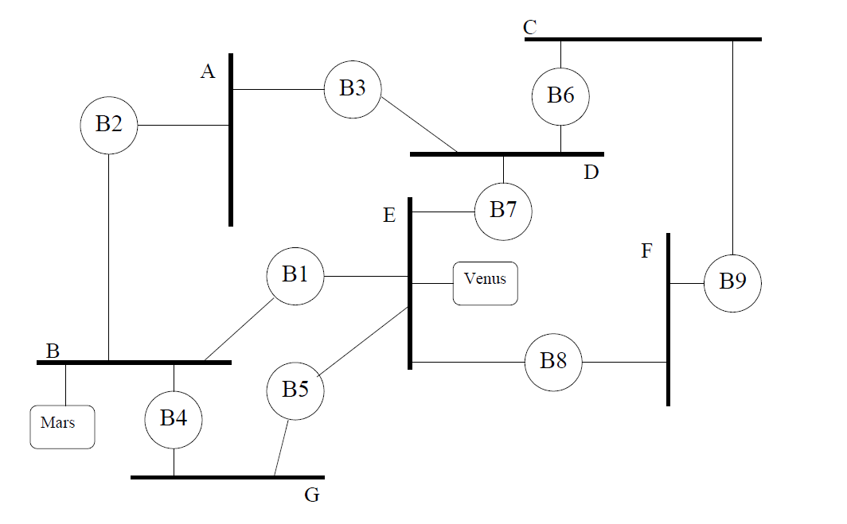

1. Indicate which bridge is root, which ports are root ports (i.e. the preferred port for reaching the root bridge), which bridge is the designated bridge for each LAN, and which ports are designated ports (i.e. the ports that connect some LAN to its given designated bridge). Hint: bridges that are not designated bridges for any LAN, and ports that are not either root ports or designated ports do not play a role in the routing of packets. The remaining bridges together with the LANs form a spanning tree.
2. Suppose after the configuration is complete, host Mars attaches to LAN B and host Venus attaches to LAN E. Suppose Mars sends a message to Venus, then Venus sends a message to Mars, then Mars sends a second message to Venus. For each of the three messages, indicate which LANs the message is heard on.